Computer Architecture and Organization
Project Report



Digital Design (25 point) | Verilog Implementation (25 point) | Verilog Testbench (25  points) | Academic Report and Presentation (25 points) | Total (100 points)

 | Student Name | Student Number | Signature
1. | Ahmet Sait Almış | 23040102057
2. | Mikhail Savuskhin | 23040102083
3. | İhsan Cemal Çınarsoy | 23040102049
4. | Dilara Çürgüç | 23040102038
5. | Ayşegül Baytekin | 22040102036

GITHUB LINK: https://github.com/m4rkellkka/priority-encoder-8to3

Project Description :
In this project, an 8-to-3 Priority Encoder with a Valid Signal is designed and implemented using Verilog HDL. An encoder is a combinational logic circuit that converts multiple input lines into a smaller number of output lines. Unlike a standard encoder, a priority encoder handles multiple active inputs simultaneously by assigning a priority level to each input. In our design, an 8-bit input (D[7:0]) is encoded into a 3-bit output (Y[2:0]). The most significant bit, D[7], has the highest priority, while the least significant bit, D[0], has the lowest. Additionally, a 1-bit Valid signal (V) is produced to indicate whether any of the input bits are actively driven HIGH.
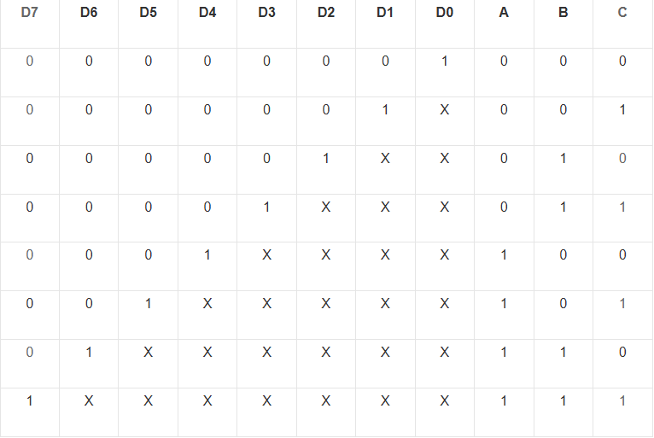
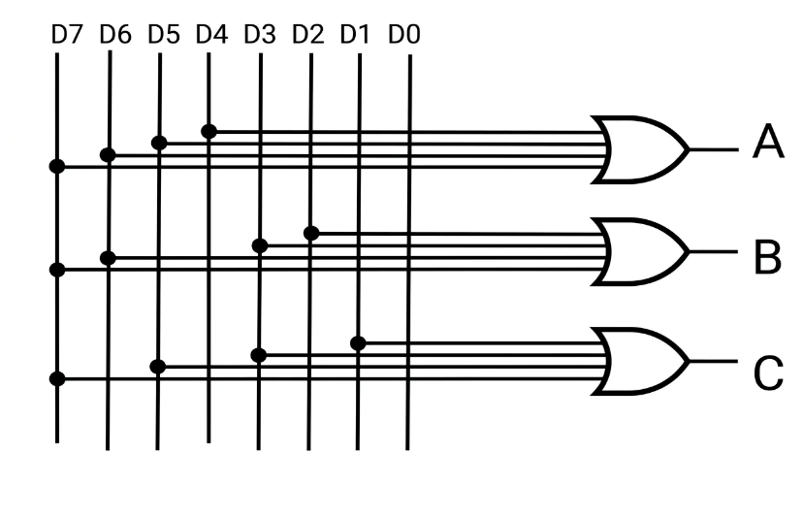
Digital Design & Schematic Explanation:
truth table - 1 Priority Logic – 2
Truth Table and Priority Logic:
The digital design is governed by the priority logic explicitly outlined in the provided truth table. In a standard encoder, having multiple inputs HIGH simultaneously would cause an invalid or overlapping output. However, our priority encoder resolves this by assigning the highest priority to the most significant bit (D7) and the lowest to the least significant bit (D0). As demonstrated in the truth table, if a higher-order bit is active (1), the lower-order bits immediately become "Don't Care" (X) conditions, meaning their physical states have no impact on the final output. For instance, if D7 is 1, the outputs A, B, and C will unambiguously evaluate to 1, 1, and 1, regardless of the states of inputs D6 through D0.
Gate-Level Schematic Analysis:
The provided schematic diagram illustrates the fundamental boolean mapping of the 8 input lines (D7 to D0) into the 3 output lines (A, B, C) utilizing OR gates. The outputs are generated based on the active inputs that correspond to their binary equivalents:
Output A (MSB): Driven HIGH when the decimal value of the active input is 4, 5, 6, or 7. Therefore, its OR gate is connected to inputs D4, D5, D6, and D7.
Output B: Driven HIGH when the decimal value of the active input is 2, 3, 6, or 7. Therefore, its OR gate is connected to inputs D2, D3, D6, and D7.
Output C (LSB): Driven HIGH when the decimal value of the active input is an odd number (1, 3, 5, or 7). Therefore, its OR gate is connected to inputs D1, D3, D5, and D7.
While the schematic visualizes the basic routing for the encoding process, the strict priority condition is enforced behaviorally in our Verilog design utilizing cascading if-else structures. This hardware description guarantees that only the active input line with the highest index is permitted to drive these logical paths.

Important Features :
Highly Optimized Valid Signal Logic: Instead of utilizing an extensive tree of complex logic gates or additional if-else branches to calculate the Valid signal, our design smartly utilizes the Verilog Bitwise OR Reduction Operator (assign V = |D;). This approach is highly optimized for hardware synthesis, reducing the physical gate count by collapsing all 8 input bits into a single wide OR-gate.
Self-Verifying Testbench: Our testbench goes beyond simply applying inputs. It is designed to be highly user-friendly and self-verifying. It prints "Expected" logic values alongside the actual hardware outputs via $display commands. This allows any evaluator to verify the correctness of the priority logic directly from the terminal without even needing to open a waveform viewer.

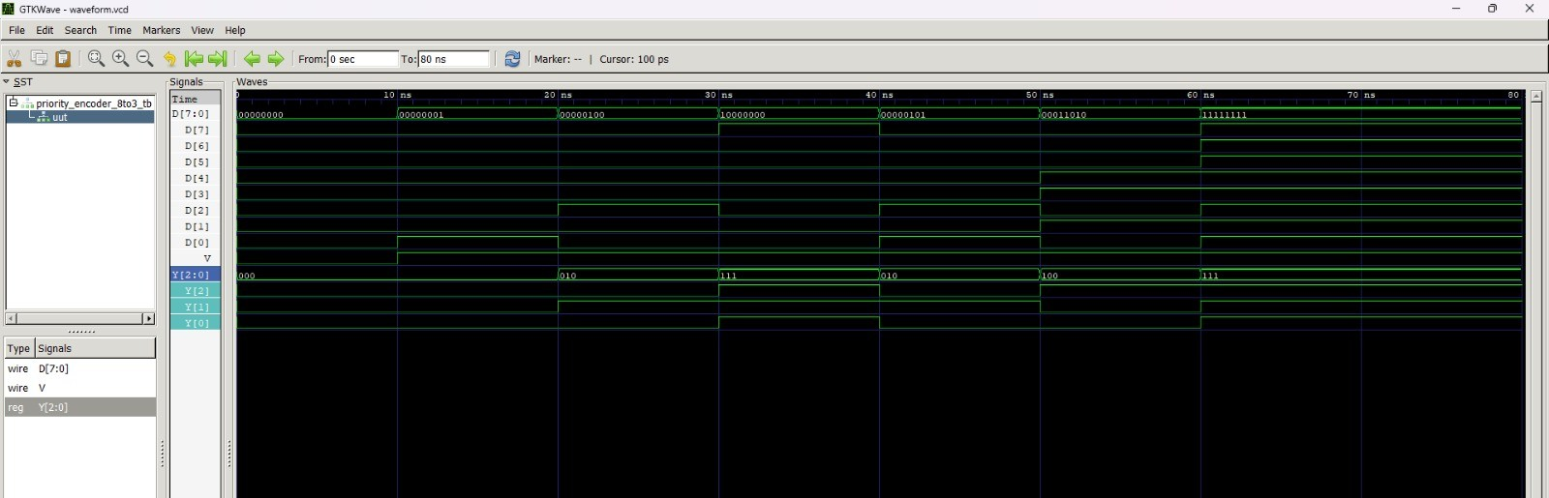
GTKWave Screenshot :

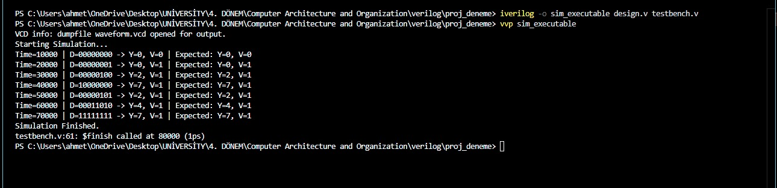
TestBench ScreenShot :

Verilog Source Code :
desing.v :
`timescale 1ns / 1ps
module priority_encoder_8to3 (
input wire [7:0] D, // 8-bit input
output reg [2:0] Y, // 3-bit encoded output
output wire V // 1-bit valid signal
);
assign V = |D;
always @(*) begin
if (D[7]) Y = 3'd7; // Highest priority
else if (D[6]) Y = 3'd6;
else if (D[5]) Y = 3'd5;
else if (D[4]) Y = 3'd4;
else if (D[3]) Y = 3'd3;
else if (D[2]) Y = 3'd2;
else if (D[1]) Y = 3'd1;
else if (D[0]) Y = 3'd0;
else Y = 3'd0;
end
endmodule
testbench.v :
`timescale 1ns / 1ps
module priority_encoder_8to3_tb;
reg [7:0] D;
wire [2:0] Y;
wire V;
priority_encoder_8to3 uut (
.D(D),
.Y(Y),
.V(V)
);
initial begin
$dumpfile("waveform.vcd");
$dumpvars(0, priority_encoder_8to3_tb);
$display("Starting Simulation...");
D = 8'b0000_0000;
#10;
$display("Time=%0t | D=%b -> Y=%d, V=%b | Expected: Y=0, V=0", $time, D, Y, V);
D = 8'b0000_0001; // Only D[0] is active
#10;
$display("Time=%0t | D=%b -> Y=%d, V=%b | Expected: Y=0, V=1", $time, D, Y, V);
D = 8'b0000_0100; // Only D[2] is active
#10;
$display("Time=%0t | D=%b -> Y=%d, V=%b | Expected: Y=2, V=1", $time, D, Y, V);
D = 8'b1000_0000; // Only D[7] is active
#10;
$display("Time=%0t | D=%b -> Y=%d, V=%b | Expected: Y=7, V=1", $time, D, Y, V);
D = 8'b0000_0101; // D[2] and D[0] are active, D[2] should have priority
#10;
$display("Time=%0t | D=%b -> Y=%d, V=%b | Expected: Y=2, V=1", $time, D, Y, V);

D = 8'b0001_1010; // D[4], D[3], D[1] are active, D[4] should have priority
#10;
$display("Time=%0t | D=%b -> Y=%d, V=%b | Expected: Y=4, V=1", $time, D, Y, V);

D = 8'b1111_1111;
#10;
$display("Time=%0t | D=%b -> Y=%d, V=%b | Expected: Y=7, V=1", $time, D, Y, V);
$display("Simulation Finished.");
#10;
$finish;
end
endmodule

